**User Manual**

**Ocean’s 7**

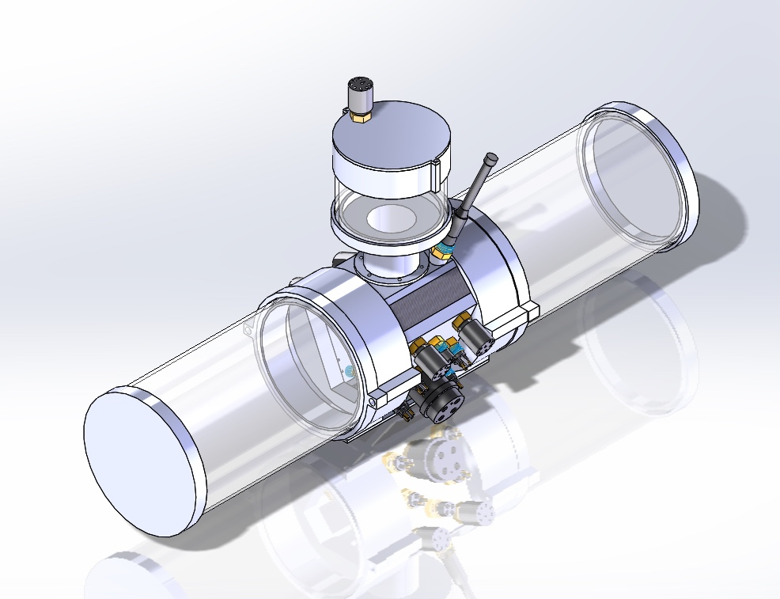

Hassan Alahmed, Abby Caballero, Kyle Harlow,

Daniel Henderson, Yuvin Kokuhennadige, Cassandra Noice

Problems

In previous years the University of Colorado Robosub has had a variety of electronics related issues. Two different vehicles had runs ended by devices being plugged in with improper polarity, and the team has had limited controls power. Usually the control algorithms were simple PID loops run on the main computer (CPU). There have also been problems with wire management.

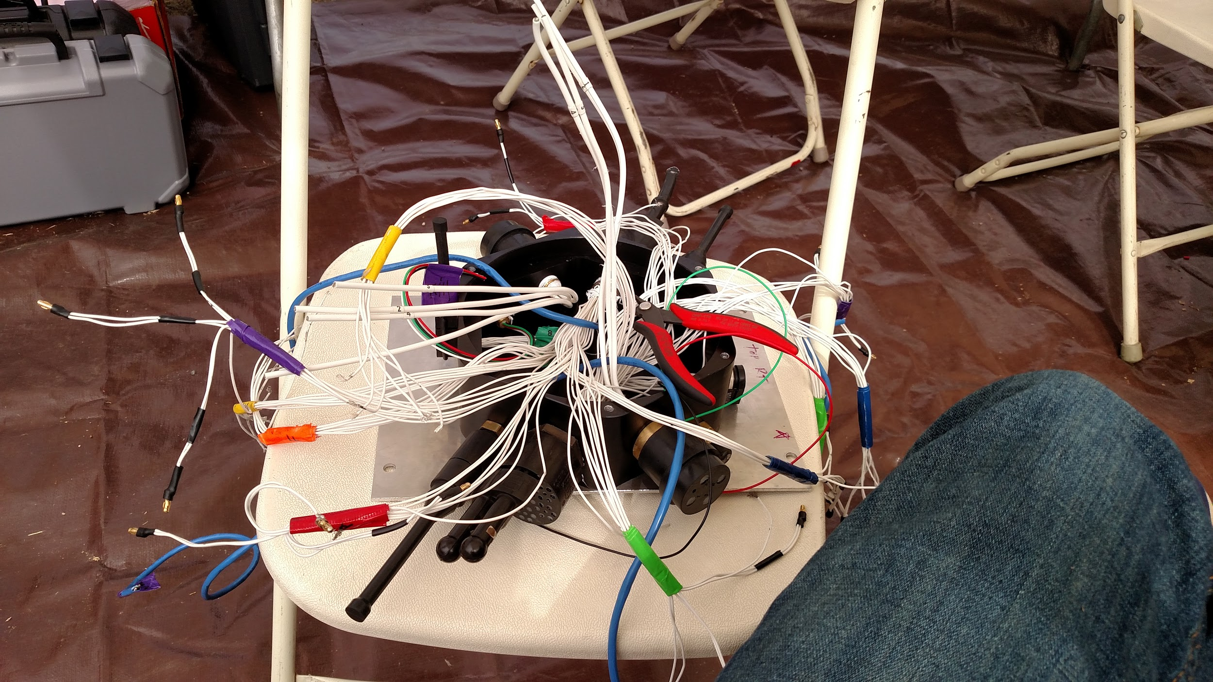

Figure 1.1: Doctor Octopus, the external to internal electrical connections required by Caligula the 2016 Vehicle

Finally, power distribution across the large variety of voltages and currents required by the vehicle has caused problems as well. Large motor currents have caused excessive heating inside the vehicle, and data transfer disruptions.

In order to solve this problem, Ocean’s 7 is designing the following three integrated systems:

1. A power system
2. A controls system
3. A backplane

The power system seeks to efficiently merge and convert power delivered from our two 14.8V, 10C, 10 Amp-Hour batteries. The controls system will execute controls algorithms to increase the stability of the vehicle while offloading that information from the main CPU. The backplane will distribute power throughout the vehicle with slots for our own conversion and controls boards, as well as additional boards possibly created by the robosub team. It will also facilitate data transfer from the main CPU to our controls board and power management unit.

User Base

There are three distinct users for our product. They will be delineated the RoboSub Team (RoboSub), the Autonomous Underwater Vehicle (AUV), and the divers. RoboSub is the team who has designed vehicles in the last three years. The team is primarily composed of engineers, many of whom will be able to determine functionality from schematics and algorithms. They will also be the group integrating the system into the AUV. The AUV is the RoboSub team's vehicle. The vehicle functions autonomously, and will be using our system to distribute power throughout the vehicle. The AUV will communicate primarily with the CPU which will be sending updated vectors for the control algorithm to head towards. The AUV will receive data from a variety of sensors, including the hydrophones array from HydroDynamics. Finally, the divers will interact with our system via the kill switch. Divers are the primary link between the RoboSub team and the AUV during competition runs and practice. They will press the killswitch to kill motors if a dangerou situation, either to personnel or the AUV arises, or to restart a run.

System Functionality

Power

The power system will be split into two major components. The first will be a merge circuit. The merge circuit will draw 100A from each battery at 14.8V and will merge the current into a single 200A trace. From there the trace will be distributed to different motors as well as a 10A trace running to the power conversion board. The power conversion board is the second major component of the power system. The power conversion board will take the 14.8V trace and convert it into 3.3V-1A, 5V-1A, 12V-1A, 14.8V-xA, 19V-4A, and 48V-1.5A traces to power the internal electronics of the vehicle.

Controls System

The control system will calculate a time optimal path using the desired vector from the CPU and data provided by two inertial measurement units (IMU)s and one Doppler Velocity Logger (DVL). From there it will control the ESC’s to maneuver properly.

Backplane

The backplane will take a 10A, 14.8V trace and pass that to the power conversion board. From there it will take outputs from the power conversion board delivering traces of 3.3V, 5V, and 12V at 1A, as well 14.8V at 5A, and 19V at 4A, and 48V at 1.5A. This power will be delivered to a variety of internal components. In addition the backplane will facilitate RS232 communication between the CPU and the controls system, as well as I2C or PWM communication between the controls system and the ESC’s.

System Usage

The Robosub team will conduct the final integration of the system. They will be responsible for plugging the boards into the main hull of the AUV. Each board will be plugged into a specific slot, however slots will be designed to fit multiple types of boards. Each board will also only be designed to fit in a single direction.

The manual kill switch will visible on the outside of the vehicle. The kill switch will be used by the divers to stop a run in a safe manner. It will shut down all motors upon activation.

The AUV will use the controls board by providing desired velocity and acceleration vectors to the board. From there the control board will adjust the speeds of each motor in order to execute that desired vector.

Limitations

The controls system is limited by the motor layout and output. The vehicle has a defined depth limit based on the mechanical hardware. In addition our power system will not be able to deliver maximum power to the AUV for an extended duration of time. This is mostly a limitation of the batteries, which expand significantly as you increase current rating, and voltage.